INTERNATIONAL SCIENTIFIC AND PROFESSIONAL CONFERENCE
EXHIBITIVE CARTOGRAPHIES III
Critical Instrumentation, Exhibitive and Curatorial Narratives

Faculty of Humanities and Social Sciences, University of Split
14 May, 2024

ORGANIZED by Faculty of Humanities and Social Sciences, University of Split, and Croatian Section of the International Association of Art Critics (AICA Croatia)

KEYNOTE LECTURER
Pedro Lorente, PhD (Full Professor of Art History at the University of Saragossa)

INVITED LECTURERS
Jovanka Popova (curator, Museum of Contemporary Art, Skopje, North Macedonia), Dalibor Prančević, PhD (Associate Professor, Department of Art History, Faculty of Humanities and Social Sciences, University of Split), Božo Kesić, PhD (Senior Assistant at the Department of Painting, Arts Academy, University of Split)

The conference is supported by Faculty of Humanities and Social Sciences, University of Split, and AICA International.

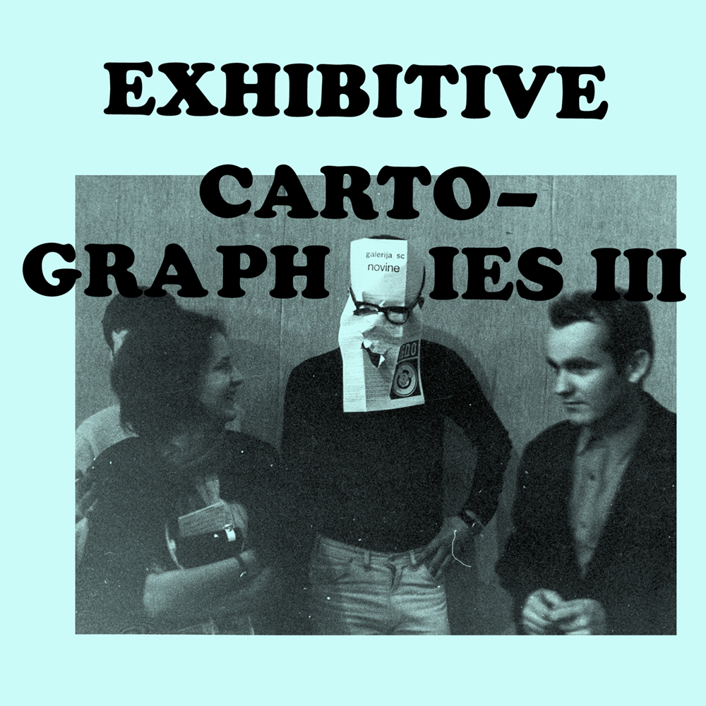

INTERNATIONAL CONFERENCE
Exhibitive Cartographies
14 May, 2024

EXHIBITIVE CARTOGRAPHIES (CRITICAL INSTRUMENTATION, EXHIBITIVE AND CURATORIAL NARRATIVES)

INTRODUCTION

The aim of this conference is to present, examine and contextualise curatorial practices in contemporary art, in Croatia and in the region, but also specifically in regard to our lecturer Pedro Lorente’s thesis on “museums as cathedrals of urban modernity”. It is important to note that the history of curatorial practices is a relatively little studied area in Croatian art history, while it is increasingly present at the international level. Our objective with this conference is to address this important subject at the crossroads of art criticism, theory and practice. There has been increasing interest in exhibition history and contextualisation of curatorial practices in art-historical research. While we can trace back exhibition history in the modern sense of a universal right to publicness to the revolutionary turmoils of the late 18th century, it was the avant-garde tendencies of the late 19th and early 20th centuries that gave the history of exhibition practices a new dimension, paving the way for innovative methods, participation and the questioning of existing institutional policies, contextual frameworks and models of presentation. The emergence of neo-avantgarde and the institutional critique of the 1950s and 1960s destabilised the conventional meanings and institutional positions of artists, artworks, curators and audiences, which led to a more active role of curators in mediating new artistic expressions, but also to radical questioning of their own position. Curators became increasingly active in the creation of meaning, assuming more and more often, with their gestures or texts, the role of meta-artists, especially in the domain of conceptual art. Redefining the position of the curator-author has increasingly come into focus since the emergence of conceptual/neo-avantgarde tendencies in art.

The starting point of the conference is the curatorial figure of Želimir Koščević, the 2018 laureate of AICA Croatia’s Annual Award and Lifetime Achievement Award. Exposed to late modernism but also to counterculture in former Yugoslavia, as a relatively young art historian, Želimir Koščević won a fellowship from Stockholm’s Moderna Museet. In 1969 – a period of radical social progress – he worked as an assistant to its then director, Pontus Hultén, in organising the legendary Poetry Must Be Made by All! Transform the World! exhibition that featured gestures and attitudes in lieu of material artworks, thereby opening up exhibition space not only for early conceptual practice but also for radical politics by encouraging supporters of Black Panthers to gather within the exhibition. The echo of the avant-garde’s entangling of life and art and the view of art as a transformative engine of social and political perception that was present in Pontus Hultén’s practice would go on to motivate Koščević to take on a more experimental and daring approach to exhibition curating, but also to question the very exhibition format, which he continued to do in his curatorial beginnings, upon his return to Zagreb. This reshaping of Koščević’s curating (and ‘student practice’) preceded his return to Zagreb and coincided with the programmatic openness and the generation’s artistic experimentation at the Student Centre in Zagreb. Koščević worked there between 1966 and 1979 as head of the SC Gallery, and during this period introduced a series of innovations to its programme. Some of the innovations in Koščević’s early curatorial approach include the exhibitions Imaginary Museum, Exhibition of Women and Men, Hit Parade, Postal Delivery and Total Action, held both outside and inside the SC Gallery. These exhibitions encouraged experimental practices and provided space to young artists; they opened up to an international exchange of ideas, interdisciplinarity, departure from the gallery and democratisation of art. A gallery newspaper was also published, aimed at self-contextualisation.

The conference is part of a wider program that includes the workshop “How to Write about Contemporary Art” which seeks to examine relations between art and contemporarity, the discourses that shape them and figures who produce them. As a follow-up to the conference, a major focus will be on analysing the role of the curator, institutional and non-institutional. The role of the contemporary art curator has radically expanded in the art world over the last several decades, and we could argue that the curatorial figure – whether one working within an institution or independently and non-institutionally – is a pivotal segment in understanding contemporary art. The main coordinates of this workshop range from drawing attention to the role of curators and curatorial collectives when acquiring relevant insights into the contemporary cultural context to examining the role of museums and galleries in contemporary society. By reviewing an exhibition event or how a particular collection is displayed, we examine the selection policies (acquisition policies, choice of exhibits). We examine how curators – with their critical and theoretical texts but also their practice – shape the history of contemporary art and anticipate/create future tendencies; we can also see how artists assume curatorial positions at museums, applying artistic methods – in lieu of linear museological narratives – such as the use of permanent collections or existing artefacts as materials, playing with the ways of seeing and with the exhibition as an all-around experience. The workshop in 2024 will be held in Zagreb, in collaboration with ULUPUH (led by Miona Muštra, with Silva Kalčić, Klaudio Štefančić and Vesna Vuković) and was already held in Rijeka, in collaboration with the Museum of Modern and Contemporary Art (MMSU) – led by Ivana Meštrov and Ksenija Orelj.

ORGANIZING COMMITTEE
Associate Professor Silva Kalčić, PhD (Faculty of Humanities and Social Sciences, University of Split), President of AICA Croatia, Associate Professor Beti Žerovc, PhD (Faculty of Arts, University of Ljubljana), Associate Professor Asja Mandić, PhD (Faculty of Humanities and Social Sciences, University of Sarajevo) and Professor Krešimir Purgar, PhD (Academy of Arts and Culture, J.J. Strossmayer University, Osijek)

ORGANIZING COMMITTEE ASSISTANT
Miona Muštra (lecturer at Academy of Fine Arts, University of Zagreb)

VISUAL IDENTITY

Niko Mihaljević. Vladimir Jakolić, photo from the Exhibition of Women and Men, June 26, 1969, Student Centre Gallery, Zagreb. Fine Arts Archives of the Croatian Academy of Sciences and Arts, Zagreb, Inv. No.: SC-46/F1

Programme and Book of Abstracts

PROGRAMME 14 May

Faculty of Humanities and Social Sciences, University of Split, Poljička Street 35

17:00 – 20:00 h
Pedro Lorente
Self-Referential Museographies in Museums of Contemporary Art as Landmarks of Critical Museology

Jovanka Popova
Curating as a Resilience Practice

Dalibor Prančević
Peripheral Discourses: Davor Matičević and his Influence on Art Scene in Split During the 1980s

Silva Kalčić
Extended Curatorial Practices of Želimir Koščević

Božo Kesić
Homeland War Memorials in Croatia – Drawing a Map

Discussion 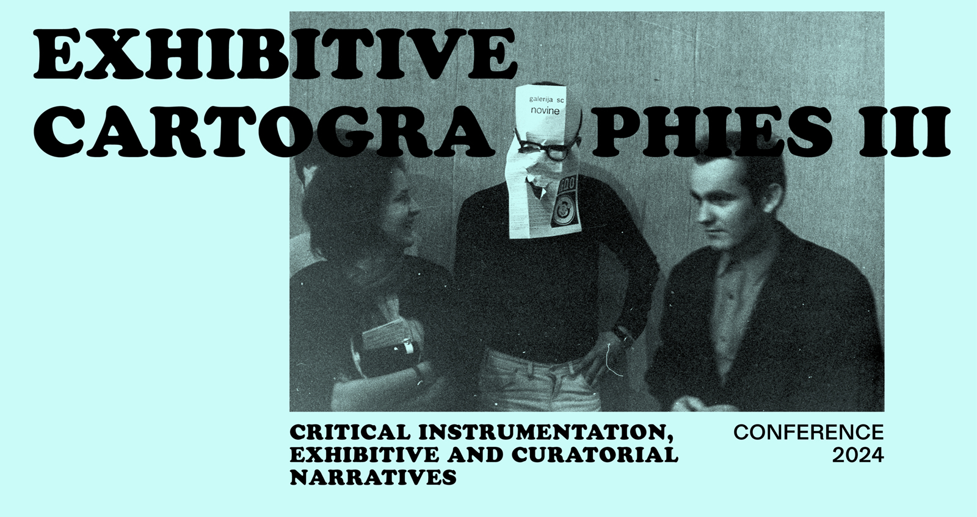

Self-Referential Museographies in Museums of Contemporary art as Landmarks of Critical Museology

Pedro Lorente

Since the 1970s, critical artists have created artwork that confronts the authority of temples of culture: this practice, known as "institutional critique," is also inspiring curatorial revisionism. It was about time! Artists have always been the foremost and keenest critics of museums; however, should museologists persist in vicariously delegating such reflexive reassessments? For a museum to be a critical institution, it is not enough to display critical art; in fact, it is more definitive to curate critically. No longer content with showing off their puzzling buildings and collections to society, museums also wish to draw attention to their own curatorial endeavours.
Critical tendencies towards museographical self-reference are gaining momentum in the 21st century. However, more particularly, a historical reconsideration vis-à-vis modernity and its modes of display is now affecting museums of modern and contemporary art. By self-referentially retrieving former displays, museums are thus offering us a reflection of themselves as narratives under permanent (re)construction. What is ultimately exhibited is the museum itself and its history. Indeed, the key point is not so much to preserve testimonies of a museum's pedigree, but to instigate museological reflections about its past and present; even more so when museums have polemically discontinued their historical presentations. Re-assessing former displays and the criteria implemented in their staging do encourage public (self)reflection about changing curatorial practices and the evolution of museography.
On the other hand, increasingly more museums are devoting specific spaces to reviewing their respective pasts, presents and futures as institutions. However, these rooms devoted to their own history tend to recurrently remain well apart from the museum's regular trail, regardless of whether they are devised as an introduction, the end of the visit, or as both. I am sorry to say that contemporary art museums rarely devote any space to telling their own history, perhaps because most of them are quite newly established institutions. Yet, some exceptional cases are producing curatorially prominent autobiographies. Most of these, I must say, are celebratory spaces that boast past and present deeds, but a critical stance can sometimes be found.
If only more museums would accompany reflections on their past with testimonies about present debates and future challenges! Art critics and cultural journalists could be excellent allies in this quest for public reflexivity in museums of modern/contemporary art by inspiring inquisitive reactions concerning the history of institutions.

Pedro Lorente (Saragosa, 1961) is Full Professor of Art History at the University of Saragossa (Spain), where he leads the research group Aragonese Observatory of Art in the Public Sphere. His last book in English, Reflections on Critical Museology: Inside and Outside Museums, was published in 2022 by Routledge. The same publisher released in 2019 his previous book: Public Art and Museums in Cultural Districts. Ashgate published in 1998 the book based on his PhD (supervised by Eileen Hooper-Greenhill at the Department of Museum Studies of Leicester University): Cathedrals of Urban Modernity: The First Museums of Contemporary Art, 1800–1930, which was the prequel to his best-known publication, The Museums of Contemporary Art: Notion and Development (also available in Spanish, French and Turkish).
Prof. Lorente is member of the editorial board of specialized journals such as Museum and Society, Museum History Journal, Museology: International Scientific Electronic Journal, MIDAS: Museus e Estudos Interdisciplinares, Culture et Musées, MODOS, ICOFOM Study Series, Journal of International Museum Education, Museo y Territorio, Revista de Museología, or Museos.es, etc.

Curating as a Resilience Practice

Jovanka Popova

“Curating as a Resilience Practice” critically explores the multifaceted role of curating in the contemporary socio-political and cultural landscape, in the field of the intersection between social clashes and cultural efficacy, contemplating whether curatorial practices can serve as agents of social solidarity, or as conduits for diverse political agendas. The narrative navigates the evolving relationship between art and politics, unveiling how art operates as a strategic tool for political intervention, economic rejuvenation, and the redistribution of geopolitical power.

Within the intricate web of cultural production, the presentation scrutinizes the delicate balance between aesthetic contemplation of politics and a deliberate avoidance of direct politicization. It also questions the challenges of maintaining a critical stance within art practices, highlighting efforts that oscillate between the limits imposed by the state, the market, and freelance activism. The final goal is to position artistic practices as integral contributors to democratic politics, portraying the role of the curator as a connector between privileged institutions and socially excluded groups.

Jovanka Popova (1980, Skopje) is a curator at the Museum of Contemporary Art – Skopje and curator and program coordinator at Press to Exit Project Space, organization for contemporary art and curatorial practices. She is a PhD candidate at the Faculty of Media and Communication, Singidunum University in Belgrade, Serbia. She has curated exhibitions in the contemporary art field in North Macedonia and worked on international curatorial projects. She was the curator of the North Macedonian Pavilion at the 58th Venice Biennale in 2019, and curator and coordinator for the 14th Manifesta Biennale in Prishtina, Parallel Program in MoCA Skopje for 2021–2023. She also presented her work at the Humboldt University, Central European University Budapest, Goethe University Frankfurt, Hankuk University of Foreign Studies, Seoul, Bahcesehir University, Istanbul, Trondheim Academy of Fine Arts and other institutions. She served as a board member at MoCA – Skopje. She was executive director of Jadro Association of the Independent Cultural Scene, North Macedonia and she was president of the Macedonian Section of AICA International Association of Art Critics.

Peripheral Discourses: Davor Matičević and his Influence
on Art Practice in Split During the 1980s

Dalibor Prančević

Davor Matičević (1945–1994), a graduate in art history and archaeology, emerged as a notable curator on the 1970s and 1980s art scene. Matičević held a longstanding position as a curator at the Gallery of Contemporary Art – Gallery of the City of Zagreb, a precursor to the present-day Museum of Contemporary Art. Notably, from 1991 until his demise, he assumed the directorship of the Museum of Contemporary Art in Zagreb. Matičević's curatorial endeavours encompassed a diverse array of projects, yet his most significant contributions had to do with the representation of visual artists in the public realm. His seminal curatorial project, Possibilities for 71, characterised the represented artists as the ‘new generation of Zagreb interventionists’, thus signalling a departure towards a novel paradigm in the artistic configuration of public spaces. This project, guided by Matičević's clear curatorial vision, aimed to connect the world of visual arts with the broader public domain – an approach echoed in the subsequent works of Želimir Koščević, whose curatorial investigations at the Student Centre Gallery in Zagreb scrutinised public space, its artistic manifestations, and audience engagement.
This presentation will delve into Davor Matičević’s curatorial pursuits in his native Split during the 1980s, spanning from the interpretation of the 'new image' phenomenon to sculptural interventions in public spaces and solo exhibitions by selected artists. The term 'peripheral' is employed herein, drawing upon the lexicon of Ljubo Karaman (1886–1971), another esteemed art historian associated with Split, who observed and described the peripheral milieu (or society) in 1963:
‘Peripheral society’ denotes a society which is positioned at a certain distance from the dominant cultural regions and which is influenced from multiple sources. By adopting and processing these various influences, such a society develops its own independent local artistic activity.

Dalibor Prančević (Split, 1972), a scholar of art history based in Split, directs his academic and professional focus towards the nuances of 20th-century art. Presently, he serves as an associate professor at the Department of Art History, Faculty of Humanities and Social Sciences, University of Split. Dr Prančević is a prolific author, contributing regularly to scholarly discourse on modern and contemporary art as well as visual culture. Additionally, he has curated numerous exhibitions showcasing modern and contemporary art.

Extended Curatorial Practices of Želimir Koščević
Silva Kalčić

The presentation raises fundamental questions about curatorial practices in contemporary art in Croatia. The history of curatorial practices is a relatively little studied area in Croatian art history, while it is increasingly present at the international level. Curatorial practices in art theory began to be associated with education, or the mediation of knowledge about art, only from the early 2000s, when the so-called “educational turn” started being discussed. The objective is to address this important subject at the crossroads of art criticism, theory and practice, with examples from exhibition history and by contextualisation of curatorial practices in art-historical research. The example of curatorial work as institutional critique is that of Želimir Koščević, a doyen of Croatian art criticism and curator. His first conceptual exhibition, and the first example of conceptual curatorial practice in the local context, was the Exhibition of Women and Men with the subtitle An Intimate Exhibition, held on June 26, 1969, from 9 p.m., at the Student Centre Gallery in Zagreb. It was conceived as a one-day “didactic” exhibition, the ninth in the gallery’s programme that year. The space in front of the Gallery was brightly lit and the doors opened at exactly 9 p.m. so that the audience enter as a crowd. The empty “white cube” of the gallery invited the audience to become the “body” of the exhibition, serving as the carriers of its content. The empty gallery was envisioned as a place for an intimate encounter between “exhibits,” confirming the transmedia nature of contemporary art. The presence of visitors with “no strings attached” was an opportunity for mutual communication and potential continuation of socialising, as they were so encouraged with a leaflet they each received at the entrance to the exhibition space. It is interesting that the audience moved along the edge of the exhibition space as if they were works at the exhibition (usually a wall display), no one wanted to go to the light-flooded centre, i.e. the central part of the gallery remained empty.

Silva Kalčić (Zagreb, 1967) obtained her MA in art history from the Faculty of Humanities and Social Sciences and her PhD from the Faculty of Architecture, Univeristy of Zagreb. She currently teaches at the Department of Art History, Faculty of Humanities and Social Sciences, University of Split. She also works as curator, critic, editor and theorist of contemporary art, architecture and design. She wrote the visual culture textbook entitled Neizvjesnost umjetnosti (2005) and authored other books, including Svijet prema labirintu. Eseji o visokoj moderni i postmodernizmu 1970-ih i 1980-ih (2017), Vlasta Delimar and Milan Božić: provesti noć u: Čakovec, Dubrovnik, Koprivnica, Pula, Ravnica, Rijeka, Slavonski Brod, Split, Varaždin, Zagreb (2015) and Izložbene kartografije Želimira Koščevića – Kritički instrumentarij, izložbeni i kustoski narativi (2024). She was the editor of journals and magazines Čovjek i prostor, Arhitektura, Oris and Zarez. She has been the president of AICA Croatia since 2019.

Homeland War Memorials in Croatia – Drawing a Map

Božo Kesić

The production of monuments has always been a largely political affair, more so in tumultuous times. Such was the period marked by the Homeland War (Croatian War of Independence) fought between 1991 and 1995. As the Republic of Croatia is a relatively young country, politics and specific geographical, historical and social circumstances still play a part in the production of artefacts such as monuments, even more conspicuously so in comparison to other institutional frameworks in which visual phenomena are made, displayed, perceived and interpreted. The aim of this presentation is to try to establish how these circumstances are reflected in recent memorials’ production in Croatia, as well as describe these processes as close as possible to terms of conventions mostly developed in the realm of (high) art, i.e. categories of authorship, presentation (exhibition-value, display of the work) and interpretation (reception and relation to the public).

Božo Kesić (Split, 1990) graduated in art history and English language and literature at the Faculty of Social Sciences, University of Split. He received his PhD degree in art history from the University of Zadar in 2023 on the subject of monuments in the Republic of Croatia. Currently, he is senior assistant at the Department of Painting, Arts Academy, University of Split. He also works as an independent curator. He is mainly interested in some aspects of modern and contemporary painting and sculpture.



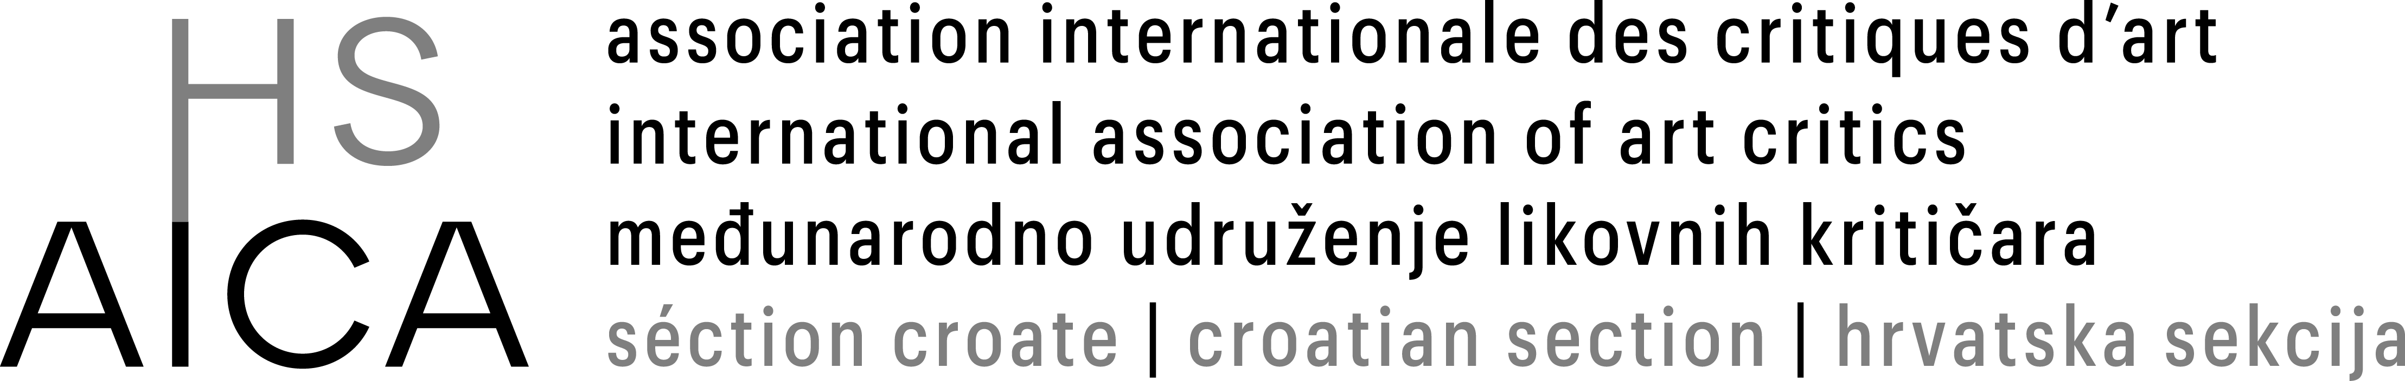

Jesus Pedro Lorente, Cathedrals of Urban Modernity: The First Museums of Contemporary Art 1800-1930, Farnham: Ashgate, 1998.

